**Department of Chemistry**

**Departmental Activities**

* **Celebration of International Year of Periodic Table – 2019**

**Activity 1 : Arrange the Periodic Table**

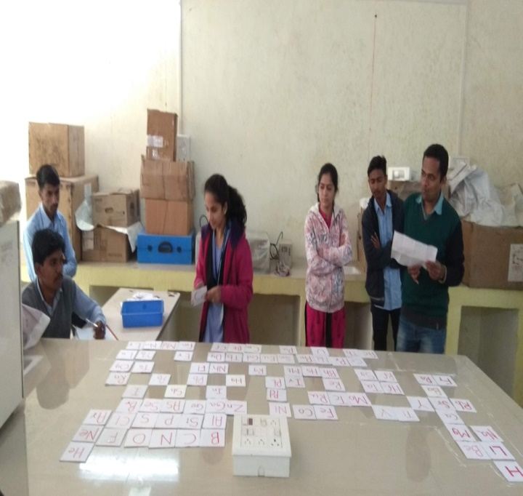 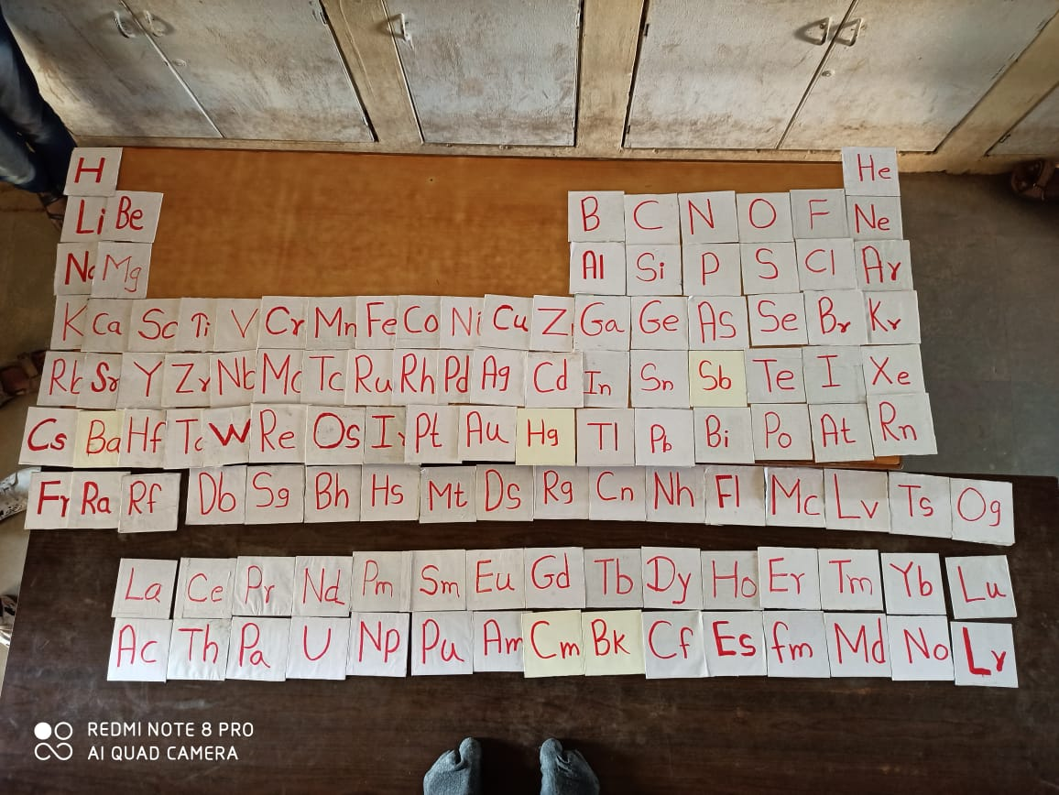

**Periodic Table arranged by Miss. Kale Dipali (M. Sc. I)**

**Activity 2 : Lecture Competition**

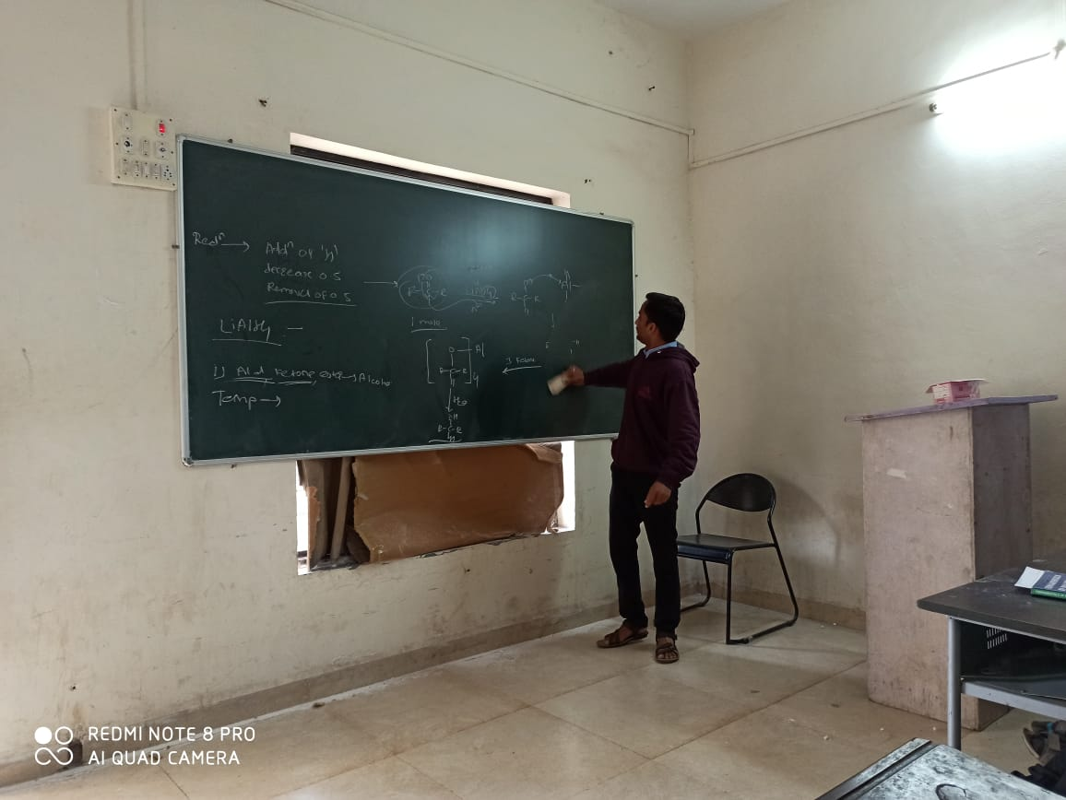 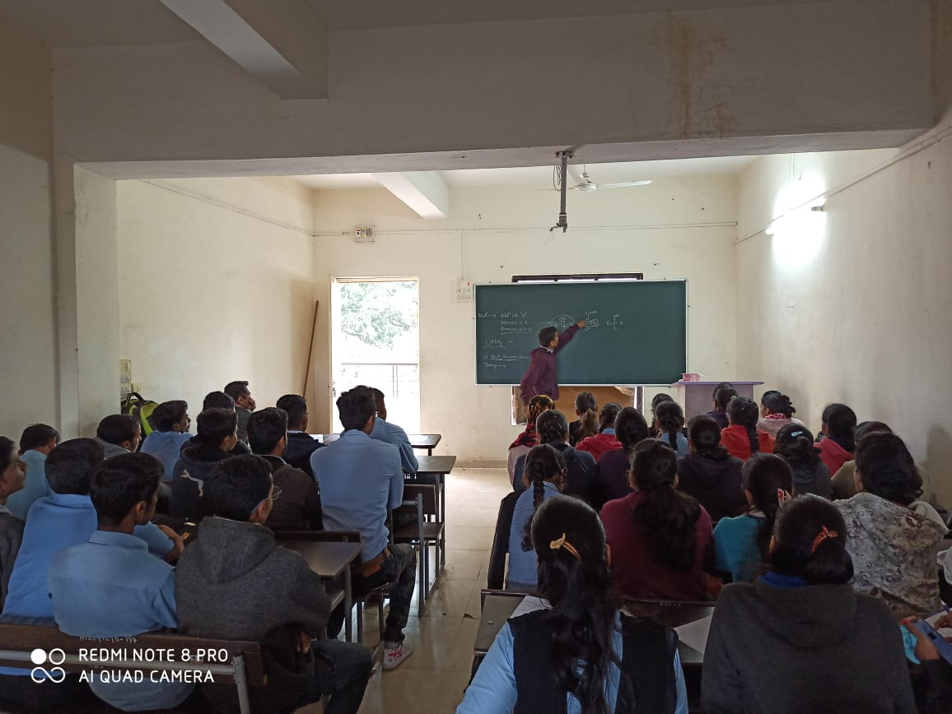

**Activity 3 : Chemquiz**

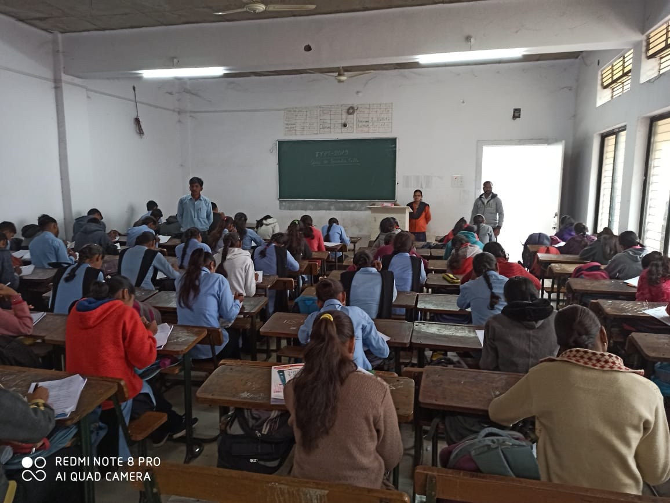 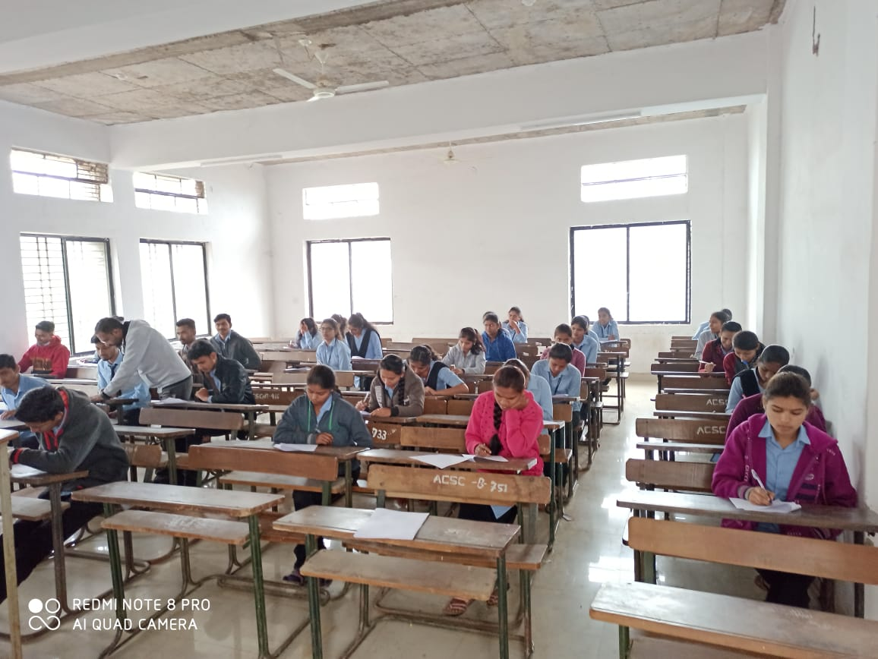

* 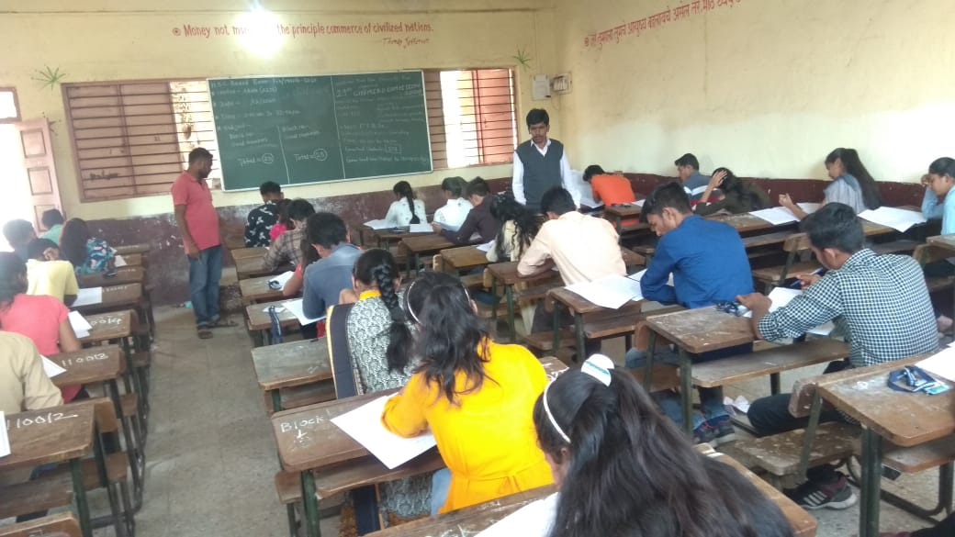**Chemiad Competition**

**Chemiad Competition- 2019**

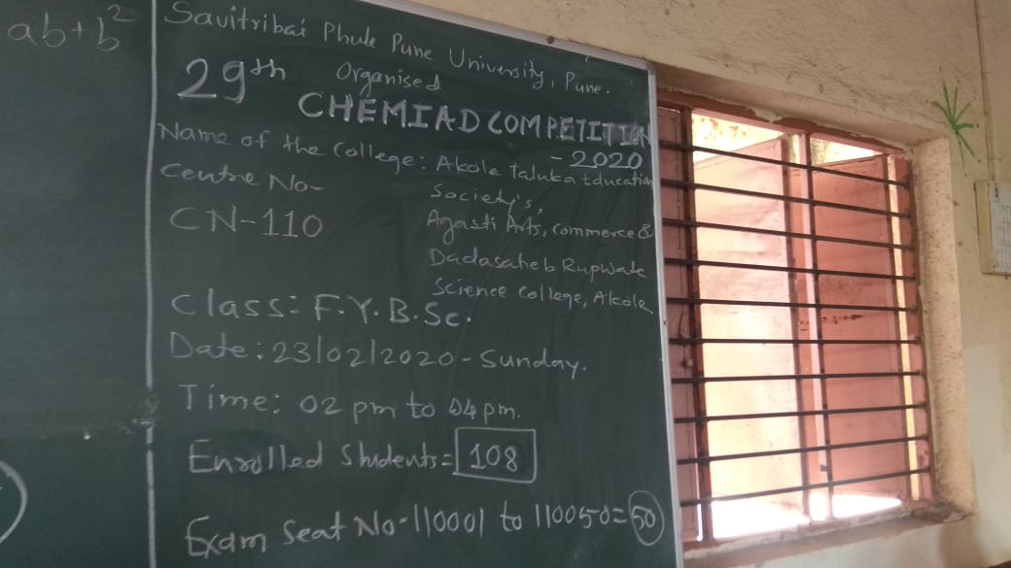

**Seating Arrangement of Chemiad Competition- 2020**

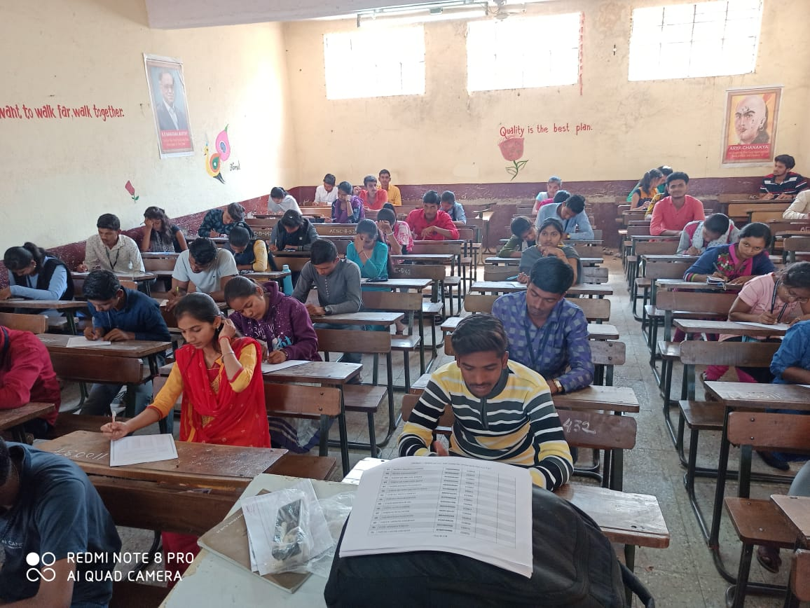

**Chemiad Competition- 2020**

* **HPCL : Swachhata Pandharwada Celebration**

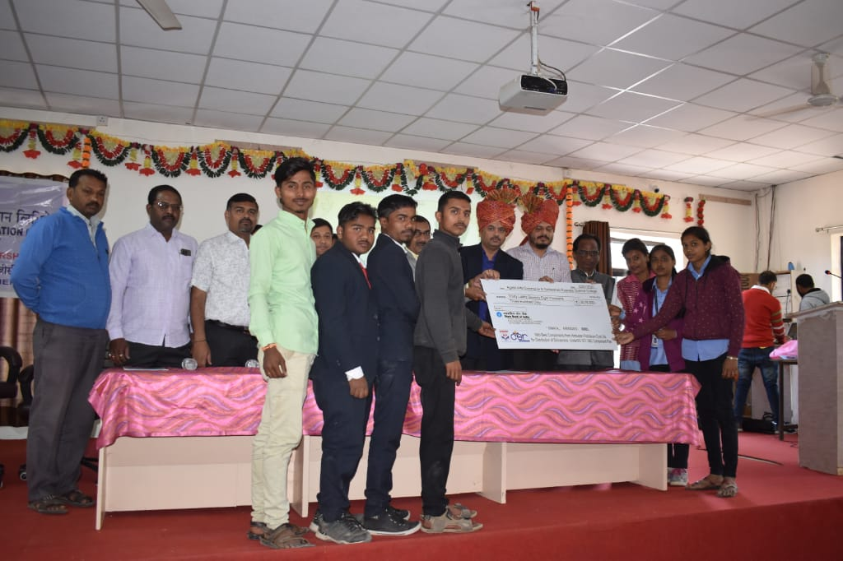

**HPCL : Scholarship Cheque Distribution**

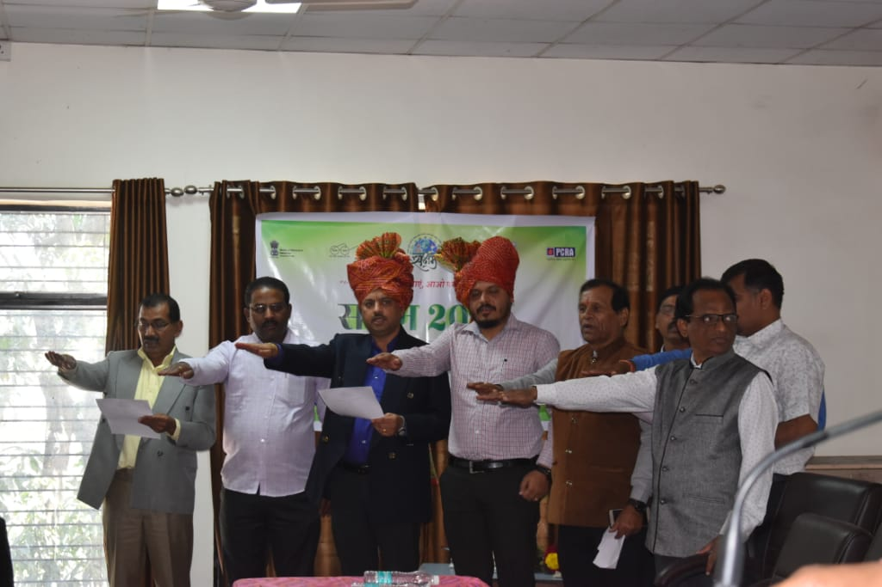

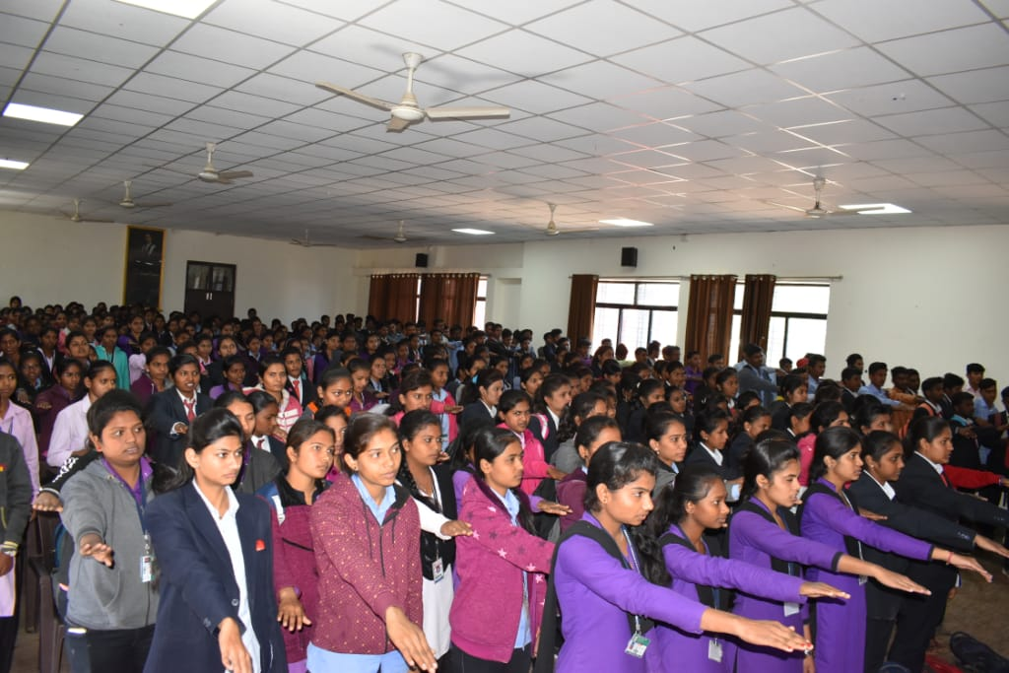

**HPCL Members, College Staff & Students are taking**

**‘Pledge of Swachhata’**

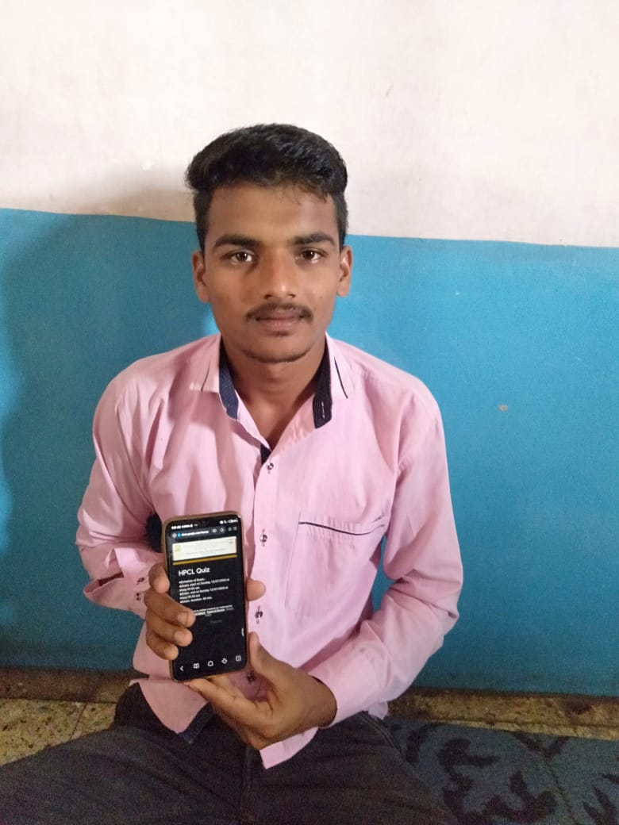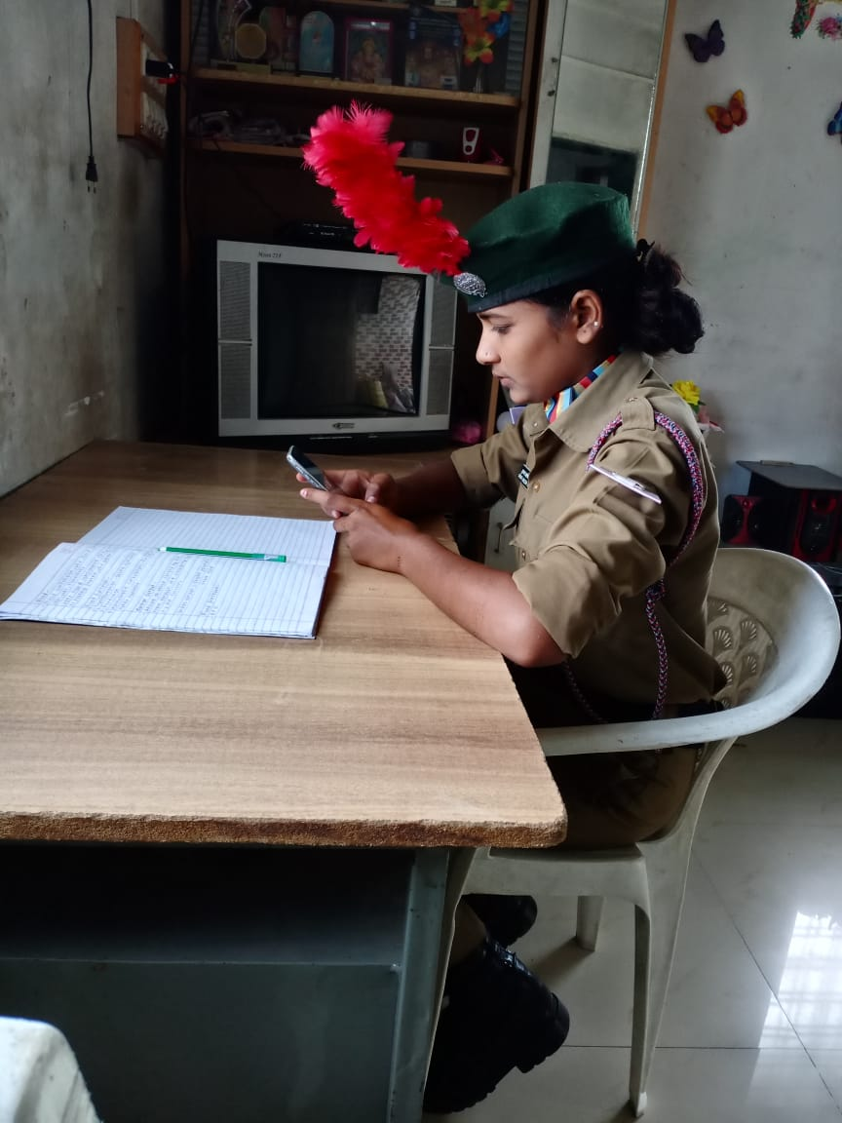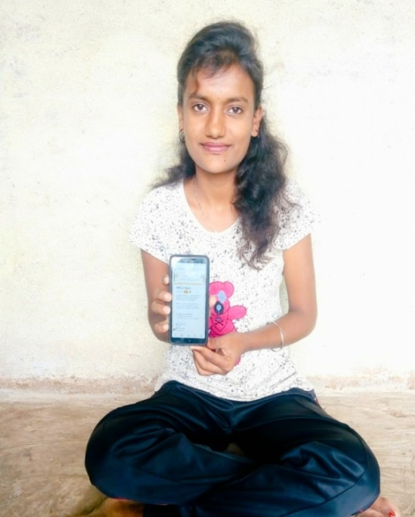

**HPCL Online Quiz : Participation of Students**

* **Special Programmes for Advanced & Slow Learners**

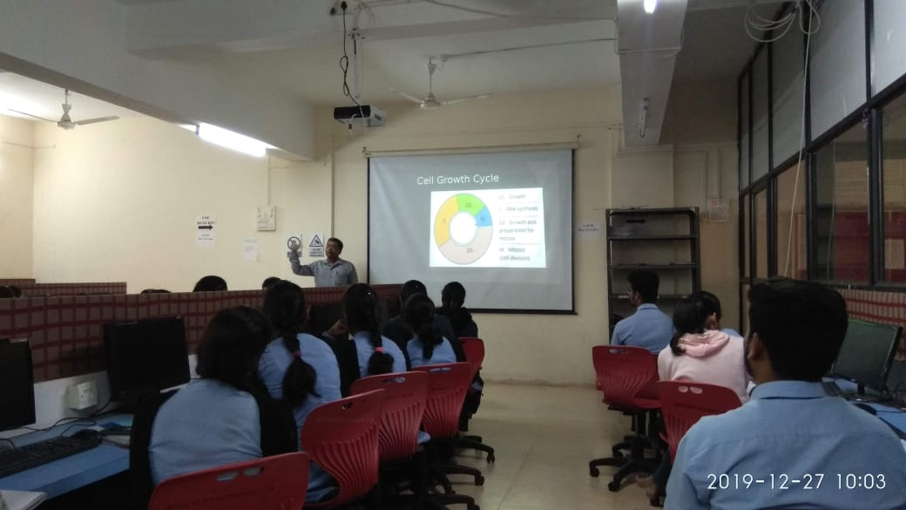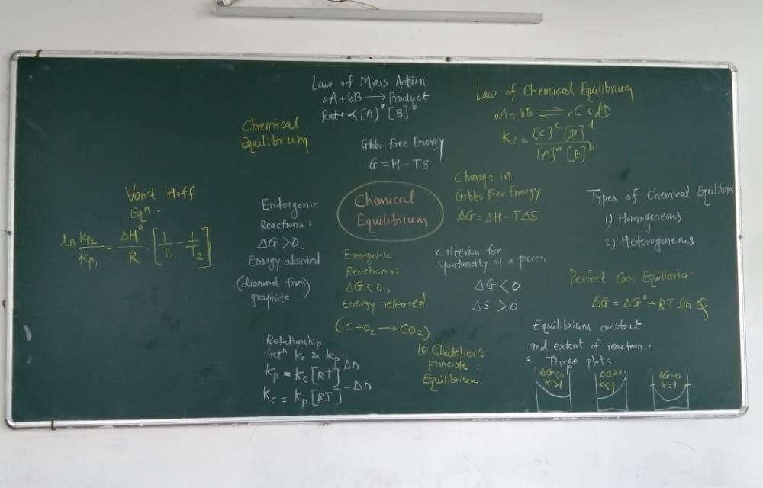

Mind Map

Guest Lecture: Prof. Dr. Mahadev Survase

* **Mentor – Mentee System for Academic & Other Related Issues**

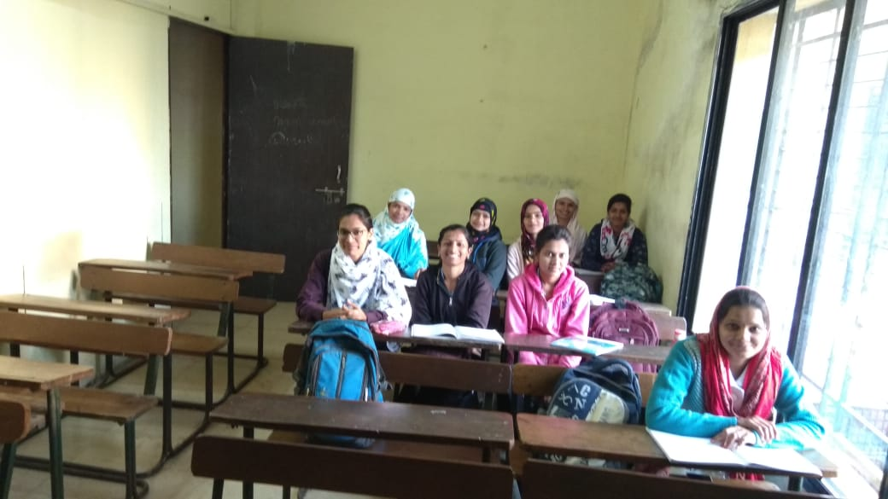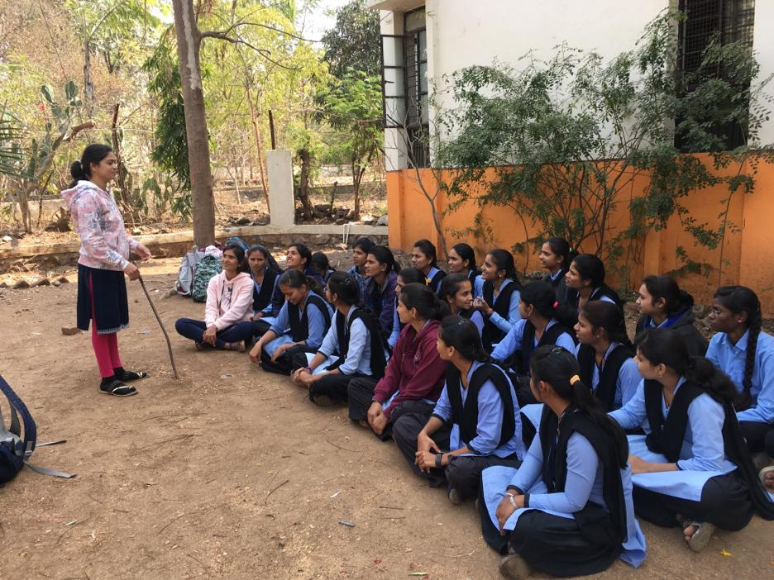

Interaction of Mentor with Mentee

* **Social Activities**
* The following Staff Members donated blood in Blood Donation Camp arranged by College.
  + **Sandesh D. Kasar**
  + **Pankaj H. Naikwadi**
  + **Arun L. Wakchaure**
  + **Jyoti S. Shinde**
  + **Tukaram R. Gaje**

